Practical 3.To study and create Master page ,user control etc.

Solution:

What is master page?

a master page is a common page whose content are shared by other pages.we can design the layout of the master page so that other pages can share it.we can have common header and footer through master pages.

Common header format

Area for different page content place holder

Common footer format

**Output screen:**

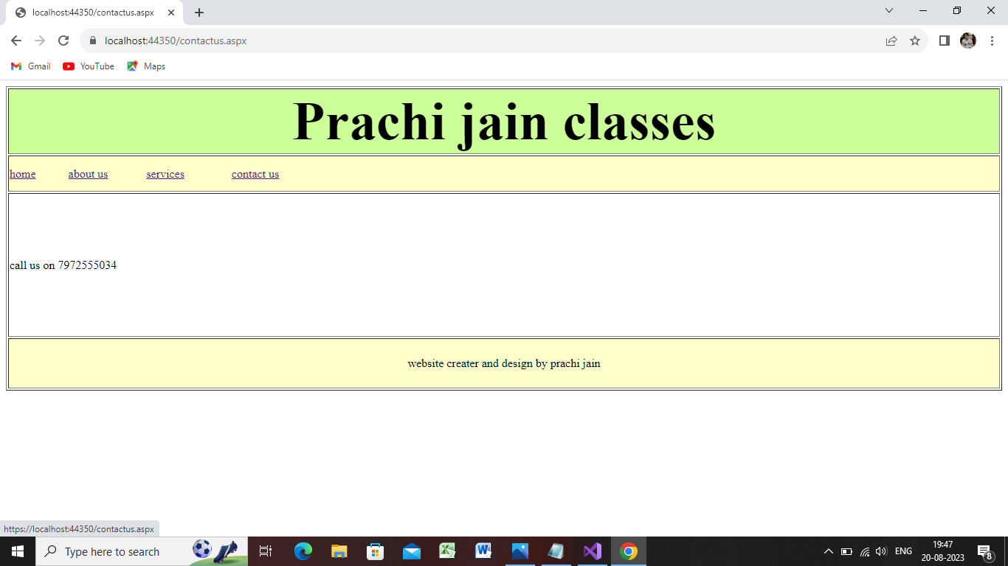

Step1:open the visual studio 2019

Step 2:take the new project

Step 3:file->new->project->asp.net web application using c#

Step 4:

Step 5:

Step 6:-right click on mymaster->add->new item->web->webforms->web forms master page->site1.master->add

You will see your master page got inserted

Step 7: now design the layout of the master page

Go to design tab->click on content place holder->table->insert table->4rows,1column->ok->resize the rows->fisrt row act as header(prachi jain classes)->adjust all rows according to output.

Step7:color the row for that set the table then press control button->select row n give green color->second row give yellow color->fourt row yellow color

Coloring done

Step 8:select the table and go to border property:->if not seen then select table tag from source then **set border property as 1**

**Step**9:insert the lable in row one and text property as prachi jain classes and set size property from property window as 45 and align as centre from menu bar

Step 10:declare or put 4 hyperlink control in row 2 and then set text property as home,,about services,contact us

Step10:in last row row 4 type directly website created and design by prachi jain

\***Step 11:now your designing done but most important your content place holder should be in row 3rd means in middle dat means ur header footer should be constant with in whole pages with in website for dat**

* **go to source page of master page dat is site1.master and check ur contenet place holder which is near by head section cut from der and place it here**

<td class="auto-style4"><asp:ContentPlaceHolder ID="ContentPlaceHolder1" runat="server"></asp:ContentPlaceHolder>

Site1.master:

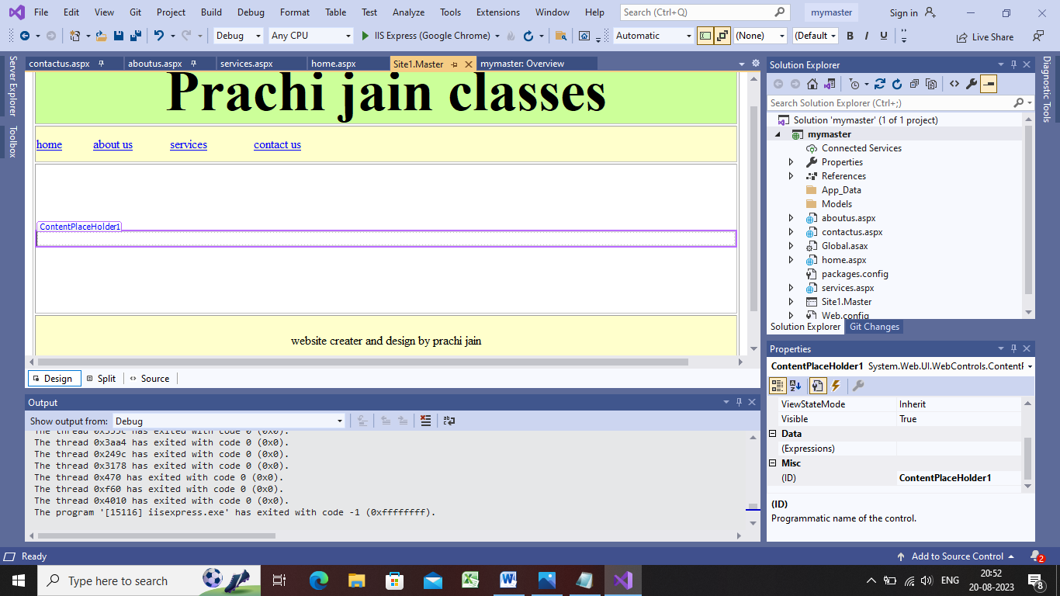

Source code site1.master:

<%@ Master Language="C#" AutoEventWireup="true" CodeBehind="Site1.master.cs" Inherits="mymaster.Site1" %>

<!DOCTYPE html>

<html>

<head runat="server">

<title></title>

<style type="text/css">

.auto-style1 {

width: 100%;

}

.auto-style2 {

height: 85px;

text-align: center;

background-color: #CCFF99;

}

.auto-style3 {

height: 45px;

background-color: #FFFFCC;

}

.auto-style4 {

height: 191px;

}

.auto-style5 {

height: 64px;

text-align: center;

background-color: #FFFFCC;

}

</style>

</head>

<body>

<form id="form1" runat="server">

<div>

<table border="1" class="auto-style1">

<tr>

<td class="auto-style2">

<asp:Label ID="Label1" runat="server" Font-Bold="True" Font-Size="55pt" Text="Prachi jain classes"></asp:Label>

</td>

</tr>

<tr>

<td class="auto-style3">

<asp:HyperLink ID="HyperLink1" runat="server" NavigateUrl="~/home.aspx">home</asp:HyperLink>

&nbsp;&nbsp;&nbsp;&nbsp;&nbsp;&nbsp;&nbsp;&nbsp;&nbsp;

<asp:HyperLink ID="HyperLink2" runat="server" NavigateUrl="~/aboutus.aspx">about us</asp:HyperLink>

&nbsp;&nbsp;&nbsp;&nbsp;&nbsp;&nbsp;&nbsp;&nbsp;&nbsp;&nbsp;&nbsp;

<asp:HyperLink ID="HyperLink3" runat="server" NavigateUrl="~/services.aspx">services</asp:HyperLink>

&nbsp;&nbsp;&nbsp;&nbsp;&nbsp;&nbsp;&nbsp;&nbsp;&nbsp;&nbsp;&nbsp;&nbsp;&nbsp;&nbsp;

<asp:HyperLink ID="HyperLink4" runat="server" NavigateUrl="~/contactus.aspx">contact us</asp:HyperLink>

</td>

</tr>

<tr>

<td class="auto-style4"><asp:ContentPlaceHolder ID="ContentPlaceHolder1" runat="server">

</asp:ContentPlaceHolder>

</td>

</tr>

<tr>

<td class="auto-style5">

<asp:Label ID="Label2" runat="server" Text="website creater and design by prachi jain"></asp:Label>

</td>

</tr>

</table>

</div>

</form>

</body>

</html>

Step 12:now we have to add other web forms with master page for that

Right click on mymaster->add->new item->web form with master page->name:homepage->add

Step 13:as u will click add button another window will open select a master page

Select site1.master->okk

Step14:add data in home page in design window as show below

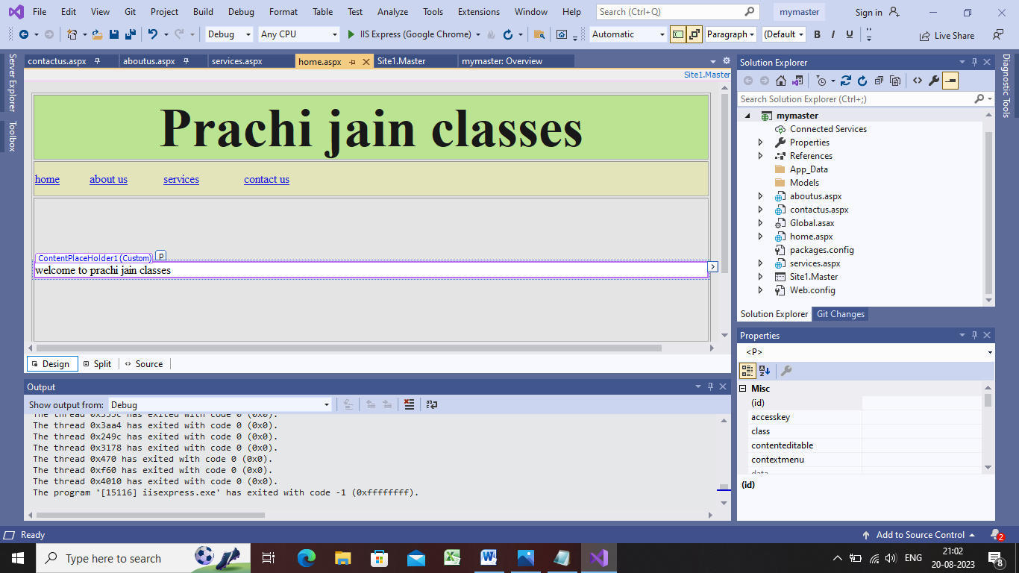

Source file of home page:

<%@ Page Title="" Language="C#" MasterPageFile="~/Site1.Master" AutoEventWireup="true" CodeBehind="home.aspx.cs" Inherits="mymaster.home" %>

<asp:Content ID="Content1" ContentPlaceHolderID="ContentPlaceHolder1" runat="server">

<p>

welcome to prachi jain classes</p>

</asp:Content>

Step 15:now we have to add other web forms again with master page for that

Right click on mymaster->add->new item->web form with master page->name:about us->add

Step 16:as u will click add button another window will open select a master page

Select site1.master->okk

Step17:add data in about us in design window as show below

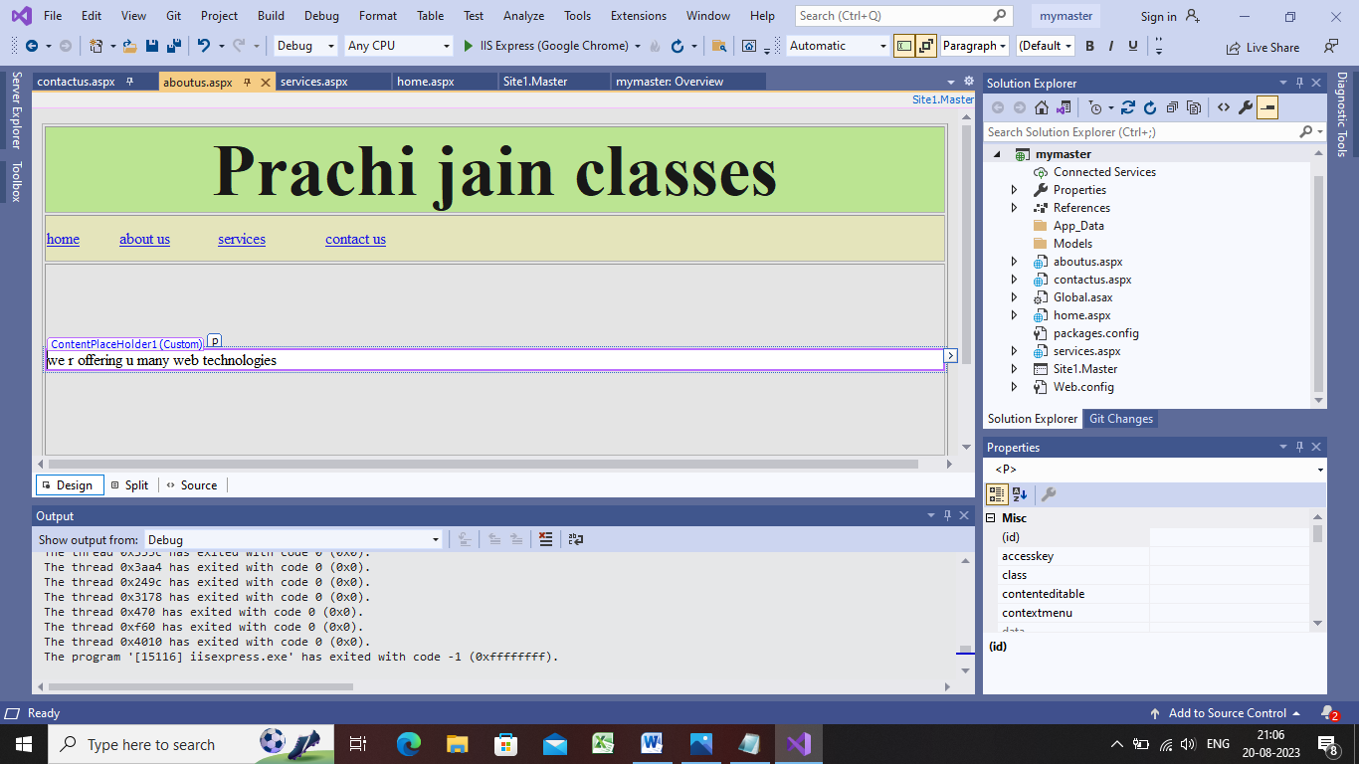

Code for about us window:

<%@ Page Title="" Language="C#" MasterPageFile="~/Site1.Master" AutoEventWireup="true" CodeBehind="aboutus.aspx.cs" Inherits="mymaster.aboutus" %>

<asp:Content ID="Content1" ContentPlaceHolderID="ContentPlaceHolder1" runat="server">

<p>

we r offering u many web technologies</p>

</asp:Content>

Step 18:now we have to add other web forms again with master page for that

Right click on mymaster->add->new item->web form with master page->name:services->add

Step 19:as u will click add button another window will open select a master page

Select site1.master->okk

Step20:add data in services in design window as show below

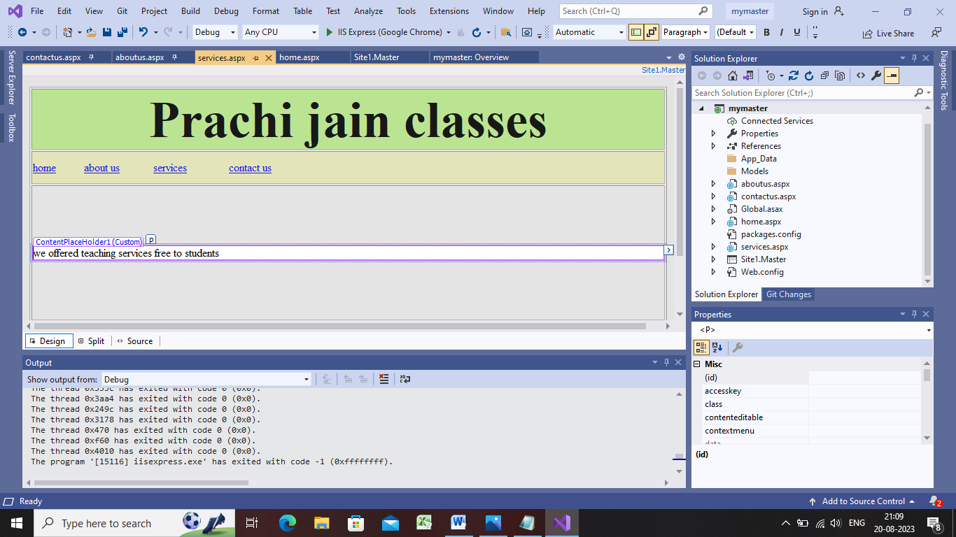

<%@ Page Title="" Language="C#" MasterPageFile="~/Site1.Master" AutoEventWireup="true" CodeBehind="services.aspx.cs" Inherits="mymaster.services" %>

<asp:Content ID="Content1" ContentPlaceHolderID="ContentPlaceHolder1" runat="server">

<p>

we offered teaching services free to students</p>

</asp:Content>

Step 21:now we have to add other web forms again with master page for that

Right click on mymaster->add->new item->web form with master page->name:contact us->add

Step 22:as u will click add button another window will open select a master page

Select site1.master->okk

Step23:add data in contact us in design window as show below

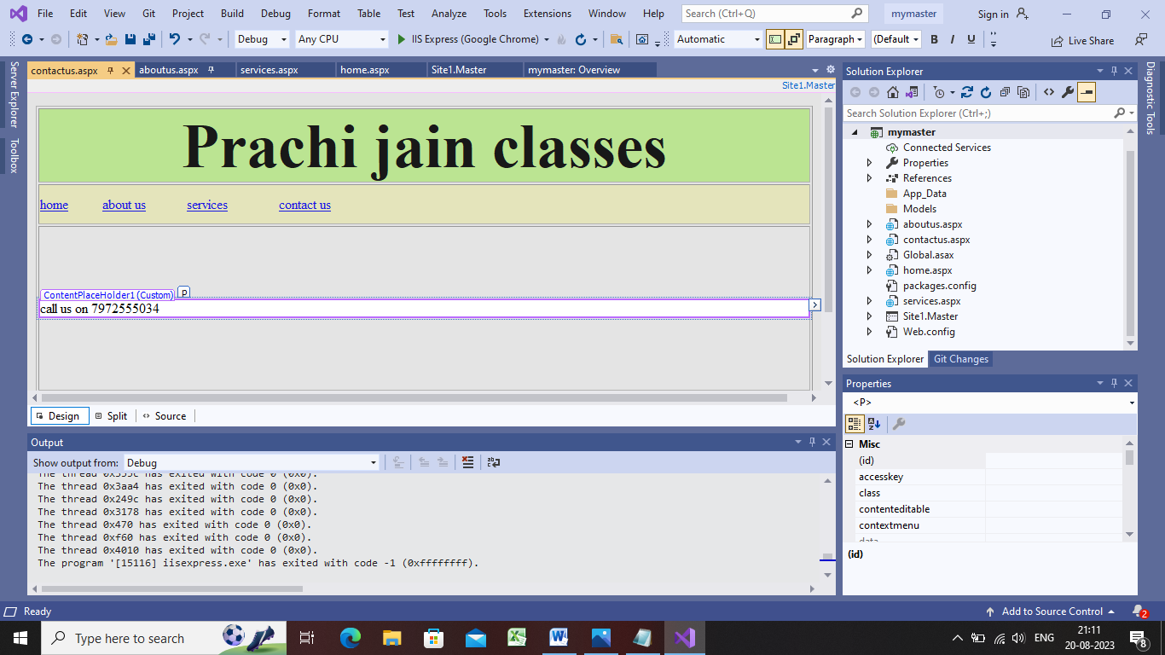

<%@ Page Title="" Language="C#" MasterPageFile="~/Site1.Master" AutoEventWireup="true" CodeBehind="contactus.aspx.cs" Inherits="mymaster.contactus" %>

<asp:Content ID="Content1" ContentPlaceHolderID="ContentPlaceHolder1" runat="server">

<p>

call us on 7972555034</p>

</asp:Content>

Step24:now we completed our four pages and they combined with master page

Step25:now go to the master page and click on home tab(home hyper link tag)->navigation url property from property window->link the pages ->all tabs link one by one

Step 26:-save everything properly

Step27:run the master page